01-NOV-2007: OcucoRelcon Announces Acquisition of SAS
OcucoRelcon has acquired the SAS (practice management software) business unit from Integrity Software for an undisclosed sum.
OcucoRelcon provides F.O.C.U.S.™ and Acuitas™ practice management systems to opticians of all sizes all over all over the UK and Ireland, now with over 1,200 supported optical sites. Through its subsidiary DRS, it also sells the market leading laboratory management systems to UK and Irish labs, LabMan.
SAS pioneered PC based systems in the UK optical software industry, and its early customers are pioneers of the optical practice computerization. The acquisition by OcucoRelcon will continue to provide these valued customers with access to the latest systems and industry initiatives in what is fast becoming the largest user base in the UK.
‘This is a very exciting move’, commented OcucoRelcon’s CEO Al Chetwode. ‘The SAS development philosophy has been very similar to our own – focussed on tangible benefits. We expect to achieve synergies through access to a larger product base and the deep well of experience the SAS team brings to the wider company.’
While the market is still seeing new entrants, the more established software players are consolidating. Mike O’Neill, business manager of SAS comments ‘It is a finite market – there are only so many independent practices in the UK, and that means there can only be a few successful suppliers. This acquisition of SAS strengthens the company’s position.’
Leo MacCanna, Ocuco Group’s Chief Executive comments “Now that the SAS team has joined us, we have a additional experienced optical management, support and development experience to add to our growing resource base and to reflect in the quality of our products, and customer satisfaction levels’.
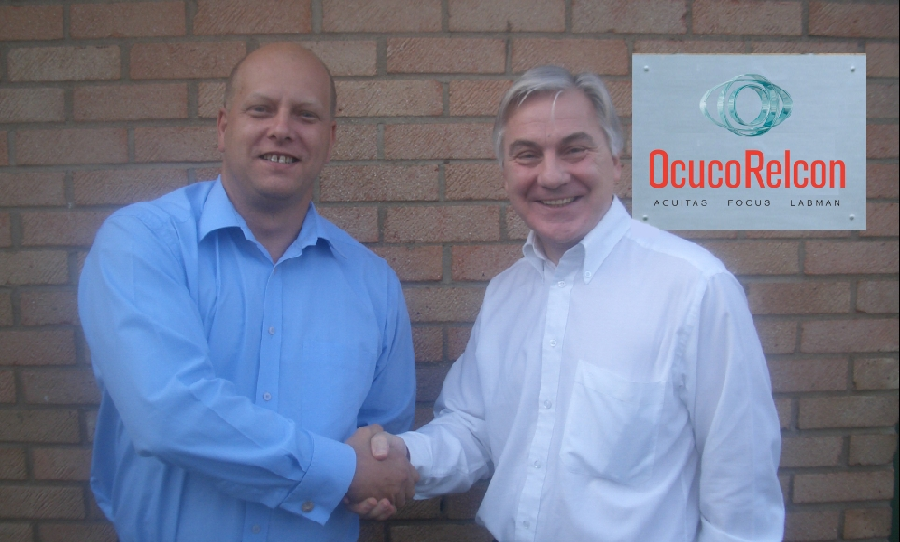

[Pictured – “Colleagues Re-united” Nigel Bedford of OcucoRelcon and Mike O’Neill of Integrity/SAS, previously colleagues at SAS for many years, come together under the same software company banner once again]
ENDS
Released by Alex Messeri
For OcucoRelcon
Unit 12, Cwrt Y Parc
Earlswood Road
Llanishen
CF14 5GH
Phone: 0870 0600428
Fax: 0870 0600429

About OcucoRelcon
OcucoRelcon provides patient relationship management software solutions – Acuitas and Focus - supporting more than 1,200 independent practices, medium sized groups and large chains, and is fast establishing the largest practice management user base in the UK.
OcucoRelcon’s full complement of software for the optical supply chain provides a unique platform on which to build partnerships in the online ordering space.
The company, which has offices in Dublin, Cardiff and Oxford, was formed by a merger of Ocuco’s and Relcon’s UK and Irish optical software divisions in August 2006.

About the Ocuco Group
Founded in Dublin in 1993, by Group CEO, Leo Mac Canna, Ocuco is a pioneer of software solutions for the ophthalmic and pharmacy markets. The company’s international launch in 1999 brought revenues to €1.5m, growing to €6m in 2006 with further growth envisaged with international expansion.
Leo Mac Canna completed an MBO in 2005, valuing the company at €5m and, following the merger with Relcon, a highly successful share distribution scheme was taken up by the majority of staff and management.
Ocuco’s strength is its ability to integrate clinical and retail, the application of leading edge technology and strong industry knowledge, accompanied by high levels of support and service.
Ocuco customers include independent and chains of High Street opticians and pharmacies, optical labs, private ophthalmology clinics, hospitals, eye A&E departments.

